2. Project Selection Justification
2.1 Project Selection Method
A weighted scoring model was used to evaluate the three proposed CoastLink Council projects. This method provides a systematic approach to project selection by identifying relevant selection criteria, assigning a percentage weight to each criterion, scoring each candidate project, and calculating an overall weighted score. This approach is appropriate because CoastLink Council must select only one project from three competing alternatives.
The weighted scoring model is one of the project-selection techniques introduced in the subject. The lecture material explains that the criteria should reflect factors such as support for business objectives, realistic technology, implementation timeframe, financial value, and risk associated with scope, time and cost.
Five criteria were selected for this evaluation:
- Organizational need.
- Expected operational benefit.
- Technical and implementation feasibility.
- Implementation risk.
- Suitability for development of a meaningful functional prototype.
The criteria and their assigned weights are shown below.
Selection Criterion | Weight
Organizational need | 25%
Expected operational benefit | 25%
Technical and implementation feasibility | 20%
Implementation risk | 15%
Prototype suitability | 15%
Total | 100%

2.2 Weighted Scoring Evaluation
Note: Each project was scored from 1 to 5, where 1 represents a very poor result and 5 represents a very strong result. The criteria weights and project scores represent the project team’s evaluation based on the project specification, business value, implementation feasibility, project risk and prototype suitability.
Criterion | Weight | Project1 | Project2 | Project3
Organizational need | 25% | 5 | 5 | 4
Expected operational benefit | 25% | 5 | 4 | 4
Technical and implementation feasibility | 20% | 2 | 5 | 4
Implementation risk | 15% | 2 | 4 | 3
Prototype suitability | 15% | 3 | 5 | 4
Weighted Total | 100% | 3.65 | 4.60 | 3.85
The weighted score for Project 1 was calculated as:
(5 * 0.25) + (5 * 0.25) + (2 * 0.20) + (2 * 0.15) + (3 * 0.15)
= 1.25 + 1.25 + 0.40 + 0.30 + 0.45
= 3.65
The weighted score for Project 2 was calculated as:
(5 * 0.25) + (4 * 0.25) + (5 * 0.20) + (4 * 0.15) + (5 * 0.15)
= 1.25 + 1.00 + 1.00 + 0.60 + 0.75
= 4.60
The weighted score for Project 3 was calculated as:
(4 * 0.25) + (4 * 0.25) + (4 * 0.20) + (3 * 0.15) + (4 * 0.15)
= 1.00 + 1.00 + 0.80 + 0.45 + 0.60
= 3.85

2.3 Selection Decision
Based on the weighted scoring analysis, Project 2: Community Facility and Maintenance Management System achieved the highest score of 4.60 out of 5.00.
CoastLink Council currently relies heavily on telephone calls, emails, spreadsheets and paper forms. The project specification states that these existing processes contribute to delays, duplicated information, inefficient use of staff and resources, and limited visibility of service performance.
Project 2 directly addresses these issues by providing an integrated system for facility availability, bookings and maintenance activities. It also has clearly defined transactional workflows, including facility searching, availability checking, booking requests, approvals, cancellations, maintenance reporting and task assignment. These workflows are appropriate for both project planning and development of a small functional prototype.
Project 1 provides potentially significant community benefits but has greater implementation complexity because emergency coordination may involve real-time prioritization, emergency resources, shelters and personnel. Project 3 is also feasible but requires greater field-operation coordination and inspection management. In comparison, Project 2 provides a strong balance between organizational value, manageable technical complexity, implementation risk and prototype suitability.
Therefore, Project 2 was selected as the preferred project for CoastLink Council.

3. Business Case
3.1 Executive Summary
CoastLink Council currently manages many community facility bookings and maintenance activities through fragmented manual and semi-manual processes. Telephone calls, emails, spreadsheets and paper forms are used across Council operations, resulting in duplicated information, processing delays and limited visibility of service performance.
The proposed Community Facility and Maintenance Management System will provide a centralized digital solution for managing Council facilities, booking activities and maintenance work. The proposed product will support facility searches, availability checking, booking requests and approvals, conflict detection, cancellations, maintenance reporting, maintenance task assignment, temporary facility closures, management of affected bookings, utilization reporting and audit history. These functions are consistent with the project description supplied by CoastLink Council.
The proposed project is expected to improve operational efficiency, reduce unnecessary administrative effort, improve information accuracy and provide better visibility of Council facilities and maintenance activities.

3.2 Current Situation
CoastLink Council provides community facilities, environmental services and emergency support across a growing coastal region. Many existing Council processes are still dependent on telephone calls, emails, spreadsheets and paper forms. The project specification identifies four major consequences of the current situation:
- Delays.
- Duplicated information.
- Inefficient use of staff and resources.
- Limited visibility of service performance.
For facility and maintenance management, these problems may result in staff having to manually check facility availability, communicate booking information through separate channels, resolve booking conflicts manually, and manage maintenance information independently from facility bookings.
A centralized information system therefore provides an opportunity to improve coordination and reduce dependence on fragmented records.

3.3 Proposed Solution
The proposed solution is a centralized Community Facility and Maintenance Management System.
The complete system design will support the following major functions:
- Facility search
- Facility availability checking
- Booking request submission
- Booking approval and rejection
- Booking conflict detection
- Booking cancellation
- Maintenance issue reporting
- Maintenance task assignment
- Temporary facility closure
- Identification and management of affected bookings
- Facility utilization reporting
- Audit history
The subject does not require a complete production-ready implementation. Instead, the project must develop a small functional prototype demonstrating selected core requirements.

3.4 Expected Benefits
The expected benefits of the proposed project include both tangible and intangible benefits.
Tangible Benefits:
Benefits | Estimated Annual Benefit
Reduced facility-booking administration effort | $40,000
Reduced maintenance coordination effort | $30,000
Reduced booking conflict and rework effort | $20,000
Reduced manual reporting and audit preparation effort | $15,000
Total Estimated Annual Tangible Benefit | $105,000
Intangible Benefits:
The project is also expected to provide the following non-financial benefits:
- Improved visibility of facility availability.
- Improved consistency of booking information.
- Faster access to maintenance information.
- Better accountability through audit history.
- Improved management information through utilization reports.
- Improved coordination between facility bookings and maintenance activities.
- Improved service experience for Council staff and community users.
The financial benefit values above are planning assumptions developed for the business case. They are intended to provide a reasonable basis for financial analysis and do not represent guaranteed future savings.

3.5 Initial Project Cost
The Council has approved a maximum initial-release budget of $300,000. The $300,000 amount is treated as a maximum constraint rather than a spending target.
The estimated project labour cost is based on the hourly charge rates provided by the subject.
Project Role | Estimated Hours | Hourly Rate | Estimated Cost
Project Manager | 180 | $110 | $19,800
Business Analyst | 220 | $90 | $19,800
Systems Analyst | 180 | $95 | $17,100
UX Designer | 140 | $85 | $11,900
Software Developer | 650 | $100 | $65,000
Data and Integration Specialist | 160 | $110 | $17,600
Test Analyst | 220 | $85 | $18,700
Training/Support Specialist | 90 | $80 | $7,200
Total Labour | 1840 hours |  | $177,100
The professional hourly charge rates are those supplied by the subject. The estimated hours are project planning estimates developed from the WBS, schedule and expected work required for each professional role.

Additional project costs are estimated as follows.
Non-Labour Cost | Estimated Cost
Software and cloud services | $4,800
Development and collaboration tools | $2,000
Integration and testing environment | $2,500
Training and deployment materials | $3,500
Total Non-Labour Cost | $12,800

Therefore,
Base Project Cost = $177,100 + $12,800
= $189,900
A contingency allowance of 10% is included to address uncertainty associated with development, integration and testing.
Contingency = $189,900 * 10%
= $18,990

Therefore,
Total Initial Project Cost = $189,900 + $18,990
= $208,890

Then,
$300,000 - $208,890 = $91,110
Therefore, the project is $91,110 below the maximum approved budget.

3.6 Ongoing Operational and Support Costs
Ongoing operational and support expenditure is reported separately from the initial project cost.
Ongoing Cost Item | Estimated Annual Cost
Cloud hosting and storage | $8,000
Application Support | $12,000
Routine software maintenance and updates | $4,000
Estimated Annual Operational Cost | $24,000
These values are planning assumptions for financial analysis.

3.7 Financial Analysis
Project Integration Management uses measures such as ROI, NPV and payback period when evaluating project investments. The payback period is defined as the time required for accumulated net cash inflows to recover the total project investment.
The estimated annual tangible benefit is:
$105,000
The estimated annual operational cost is:
$24,000
Therefore, estimated annual net benefit is:
$105,000 - $24,000 = $81,000
Payback Period = $208,890 / $81,000 = 2.58 years
Therefore, the estimated initial investment would be recovered after approximately 2 years and 7 months, subject to the assumptions used in the business case.

3.8 Three-Year Return on Investment
Three-year net operating benefit:
$81,000 * 3 = $243,000
Net financial return after initial project expenditure:
$243,000 - $208,890 = $34,110
Therefore,
ROI = ($34,110 / $208,890) * 100
= 16.3%

3.9 Net Present Value
For planning purposes, a 5% annual discount rate is assumed.
Year | Net Cash Flow | Discounted Value
Year 0 | -$208,890 | -$208,890
Year 1 | $81,000 | $77,143
Year 2 | $81,000 | $73,469
Year 3 | $81,000 | $69,971

Therefore,
NPV = -208,890 + 77,143 + 73,469 + 69,971
= +$11,693
The estimated NPV is positive. Under the stated assumptions, the discounted financial benefits over the three-year analysis period exceed the initial project investment.

3.10 Feasibility Analysis
The subject describes feasibility analysis as determining whether a project is technically and organizationally feasible and worthwhile from a business perspective.
Feasibility Area | Assessment | Justification
Technical Feasibility | Feasible | The proposed functions can be implemented using established web, database and workflow technologies.
Organizational Feasibility | Feasible | The proposed system supports CoastLink Council’s facility-booking and maintenance activities and addresses the problems identified in the current processes.
Business Feasibility | Feasible | The estimated initial cost is $208,890, which is below the $300,000 maximum budget, and the financial analysis produces a positive three-year NPV under the stated assumptions.
Overall, the business case supports proceeding with the Community Facility and Maintenance Management System.

- Requirements and Project Scope
The project specification requires the final report to include functional and non-functional requirements, a project scope statement, major deliverables, exclusions and acceptance criteria.
The scope-management lecture also explains that a project scope statement should contain a product scope description, acceptance criteria, deliverables, boundaries, constraints and assumptions.

  - Functional Requirements
- The system shall allow users to search for available Council facilities.
- The system shall allow users to check facility availability for a selected date and time.
- The system shall allow users to submit a booking request for an available facility.
- The system shall allow authorized Council staff to approve or reject booking requests.
- The system shall detect overlapping booking requests for the same facility and time period.
- The system shall allow authorized users to cancel an existing booking.
- The system shall allow users or Council staff to report a maintenance issue associated with a facility or item of equipment.
- The system shall allow authorized staff to assign maintenance tasks to responsible personnel or contractors.
- The system shall allow authorized staff to record temporary facility closures and identify bookings affected by the closure.
- The system shall allow users to view the current status of relevant booking or maintenance requests.
- The system shall produce facility utilization information for authorized Council staff.
- The system shall maintain an audit history of important booking and maintenance actions.

  - Non-Functional Requirements
- Under normal prototype operating conditions, common facility searches and availability enquiries should return a result within approximately three seconds.
- The interface shall provide consistent navigation and clear feedback for booking and maintenance activities.
- Administrative functions shall only be available to authorized users. (OWASP Foundation 2025)
- Mandatory input fields shall be validated before a booking or maintenance transaction is accepted. (OWASP Foundation 2025)
- Booking and maintenance information shall be stored consistently and protected from unauthorized modification.
- Important booking, approval, cancellation and maintenance actions shall be traceable through an audit record. (OWASP Foundation 2025)
- The proposed design should support maintenance and future extension of individual functional modules.
- Appropriate backup and recovery procedures should be defined for important system records. (Swanson et al. 2010)

  - Project Scope Statement
The Community Facility and Maintenance Management System project includes the analysis, design, prototype development, integration, testing and demonstration of a digital system for managing CoastLink Council facilities, bookings and maintenance activities.
The complete product design will include facility search and availability checking, booking request submission, booking approval and rejection, conflict detection, booking cancellation, maintenance issue reporting, maintenance task assignment, temporary facility closure, affected-booking management, utilization reporting and audit history.
The project will also produce the relevant project-management artefacts, including project-selection analysis, business case, requirements documentation, scope statement, WBS, WBS dictionary, ProjectLibre schedule, cost and effort estimates, testing evidence and final project documentation.
The project will develop a small functional prototype, rather than a complete production-ready Council system, in accordance with the project specification.

6.4 Prototype Scope
The principal functional prototype will demonstrate the following end-to-end booking scenario:
Facility Search – Availability Check – Booking Request – Conflict Validation – Staff Approval or Rejection – Booking Result
This scenario allows a user to enter or select information, complete a sequence of connected actions, and receive a meaningful result, as required by the project specification.

6.5 Major Deliverables
Major Deliverable | Description
Project selection evaluation | Evaluation and justification of the selected project
Business case | Current situation, cost-benefit analysis, financial analysis and feasibility
Project charter | Project objectives, budget, schedule, roles and responsibilities
Requirements and scope | Functional/Non-Functional requirements, scope, exclusions and acceptance criteria
WBS and schedule | WBS, WBS dictionary and ProjectLibre schedule
User interface design | Complete interface design for the proposed product
Functional prototype | Working prototype demonstrating at least one end-to-end scenario
Testing evidence | Test cases and test results
Final report | Final project report and supporting artefacts

6.6 Project Exclusions
The following functions are outside the scope of the initial release:
- Online payment processing
- Event ticket sales
- Native iOS or Android applications
- Internet-of-Things facility monitoring
- Payroll and contractor invoicing
- Emergency incident coordination functions from Project 1
- Environmental field-operation functions from Project 3
- Full integration with all existing Council enterprise systems
- Full production deployment across all CoastLink Council facilities
These exclusions are intended to prevent uncontrolled expansion of the project scope.

6.7 Project Constraints
The principal project constraints are:
- The initial-release budget must not exceed $300,000
- The final deliverable is due by 5:00 pm Friday, 16 October 2026
- The project must produce a functional prototype, rather than a complete production system
- Project activities must be completed using the available project-team resources
- Scope, time and cost must remain consistent with the approved project baseline

6.8 Project Assumptions
The project is based on the following assumptions:
- Council representatives will provide sufficient clarification where required
- Standard web application and relational database technology is suitable
- The prototype will use fictional but realistic sample data
- External enterprise-system integrations are not required for the prototype
- Reasonable development tools and cloud services will be available
- The professional hourly rates supplied by the subject are used for cost planning
- All financial benefit estimates are business-case planning assumptions rather than guaranteed savings

6.9 Acceptance Criteria
Deliverable/Area | Acceptance Criterion
Requirements | Core Project 2 functions are clearly documented and traceable to the project scope.
UI Design | Major product functions are represented through a consistent interface design.
Facility Search | A user can search for a Council facility using defined search criteria.
Availability | A user can obtain availability information for a selected facility and time.
Booking | A valid booking request can be submitted.
Conflict Detection | The prototype identifies or prevents a conflicting booking.
Approval Workflow | An authorized staff user can approve or reject a booking request.
Maintenance | Maintenance functions are included in the complete product design but are outside the selected end-to-end functional prototype unless subsequently implemented.
Validation | Required fields and invalid inputs generate appropriate feedback.
Testing | Core prototype functions pass the documented functional test cases.
End-to-End Scenario | At least one connected user scenario can be successfully demonstrated from input to meaningful result.

6.10 Product Design and Prototype Implementation Scope
Function | Complete Product Design | Functional Prototype
Facility Search | Included | Implemented
Availability Checking | Included | Implemented
Booking Request | Included | Implemented
Conflict Detection | Included | Implemented
Booking Approval/Rejection | Included | Implemented
Booking Result/Feedback | Included | Implemented
Booking Cancellation | Included | Not Implemented
Maintenance Reporting | Included | Not Implemented
Maintenance Task Assignment | Included | Not Implemented
Temporary Facility Closure | Included | Not Implemented
Affected Booking Management | Included | Not Implemented
Utilisation Reporting | Included | Not Implemented
Audit History | Included | Not Implemented

- WBS, WBS Dictionary and Project Schedule
The WBS is a deliverable-oriented grouping of project work that subdivides project deliverables into smaller work packages.
The project specification requires the report to contain the WBS, WBS dictionary and ProjectLibre outputs showing activities, dependencies, milestones, resources, costs, critical path and project baseline.

  - Work Breakdown Structure
- Project Initiation and Selection
  - Group Formation and Role Allocation
  - Review of Proposed Projects
  - Weighted Scoring Evaluation
  - Project Selection and Justification
  - Week 5 Progress Presentation
- Business Analysis and Project Planning
  - Current Situation Analysis
  - Business Case Development
  - Cost-Benefit and Financial Analysis
  - Feasibility Analysis
  - Project Charter Development
- Requirements and Scope Management
  - Functional Requirements
  - Non-Functional Requirements
  - Project Scope Statement
  - Stakeholder Analysis
  - Communication Plan
  - Project Exclusions and Constraints
  - Acceptance Criteria
- Project Schedule, Risk and Cost Planning
  - Work Breakdown Structure
  - WBS Dictionary
  - ProjectLibre Schedule
  - Risk Identification and Analysis
  - Risk Response Planning
  - Effort Estimation
  - Cost Estimation
- User Interface and Prototype Design
  - Main Screen Design
  - Facility Search and Availability Screens
  - Booking Request Screen
  - Conflict Detection and Validation Design
  - Approval/Rejection Screen
  - Maintenance and Reporting Interface Design
  - End-to-End Booking Workflow Review
- Functional Prototype Development
  - Development Environment Setup
  - Facility Search Function
  - Availability Checking Function
  - Booking Request Function
  - Conflict Detection Function
  - Staff Approval/Rejection Function
  - Booking Result and User Feedback
  - Sample Data and Input Validation
  - Prototype Integration
- Testing, Change Management and Finalisation
  - Change Request Analysis
  - Approved Change Implementation
  - Test Plan Preparation
  - Functional Testing
  - Integration Testing
  - Bug Fixing and Retesting
  - ProjectLibre Progress Update
  - Final Report Compilation
- Project Closure and Submission
  - Final Prototype Review
  - Final Project Documentation
  - GitHub and Contribution Evidence
  - Final Assessment Submission
  - Final Presentation and Demonstration

  - WBS Dictionary
WBS ID | Work Package | Description
1.0 | Project Initiation and Selection | Establish the team, evaluate the three candidate Projects, select Project 2 and prepare the Week 5 progress presentation.
2.0 | Business Analysis and Project Planning | Develop the business case, financial analysis, feasibility analysis and project charter.
3.0 | Requirements and Scope Management | Define functional and non-functional requirements, scope, stakeholders, communication needs, exclusions and acceptance criteria.
4.0 | Schedule, Risk and Cost Planning | Prepare the WBS, WBS Dictionary, ProjectLibre schedule, risk analysis and project effort/cost estimates.
5.0 | User Interface and Prototype Design | Design the complete product interface and finalise the booking workflow used in the functional prototype.
6.0 | Functional Prototype Development | Implement the selected booking scenario from facility search through booking result using sample data and validation.
7.0 | Testing, Change Management and Finalisation | Analyze and implement approved changes, test the prototype, correct defects and finalise project documentation.
8.0 | Project Closure and Submission | Review deliverables, prepare contribution evidence, submit the final assessment and prepare the final presentation.

  - ProjectLibre
ProjectLibre Desktop supports Gantt scheduling, dependencies, calendars, milestones, critical path, baselines, and single-project resource and cost management (ProjectLibre n.d.).
ProjectLibre was used to develop and manage the project schedule based on the approved WBS. The schedule includes task durations, start and finish dates, dependencies, milestones, professional resource assignments and planned labour costs.
The ProjectLibre resource assignments represent the professional project resources used for schedule and cost planning. These professional resources are separate from the student team responsibilities recorded in the weekly group checklists. The hourly charge rates supplied by the subject were used for resource cost planning.

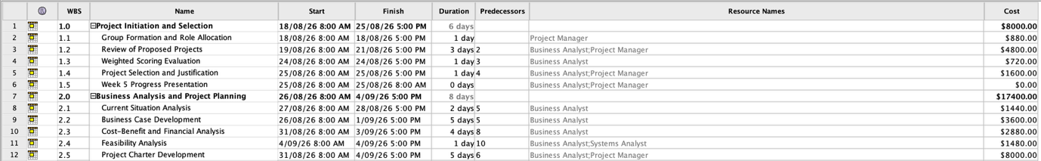
Figure 7.1A ProjectLibre Schedule Table – Project Initiation, Selection and Business Planning

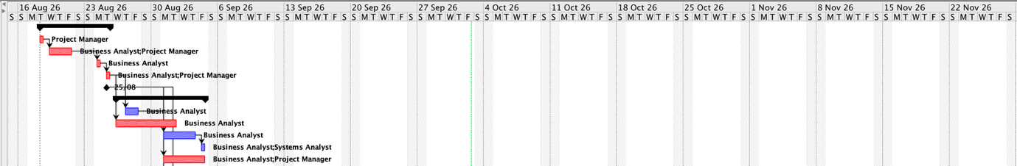
Figure 7.1B ProjectLibre Gantt Chart – Project Initiation, Selection and Business Planning

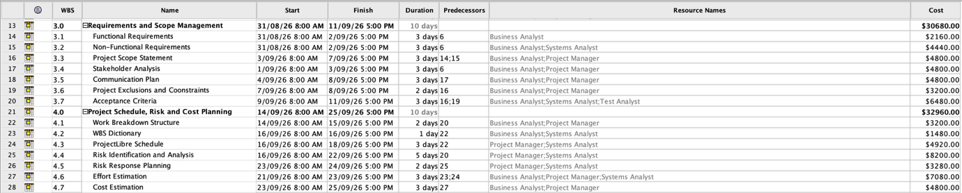
Figure 7.2A ProjectLibre Schedule Table – Requirements, Scope and Project Planning

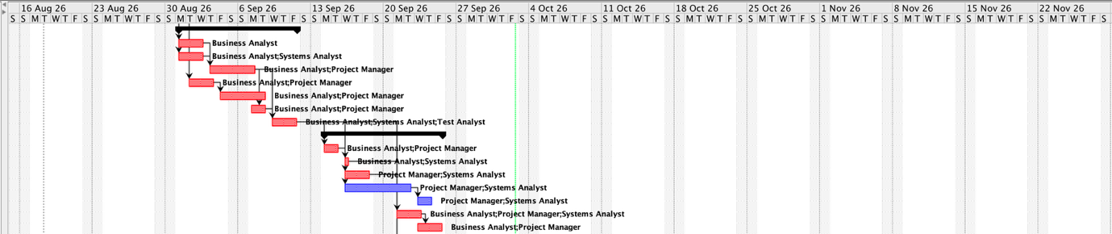
Figure 7.2B ProjectLibre Gantt Chart – Requirements, Scope and Project Planning

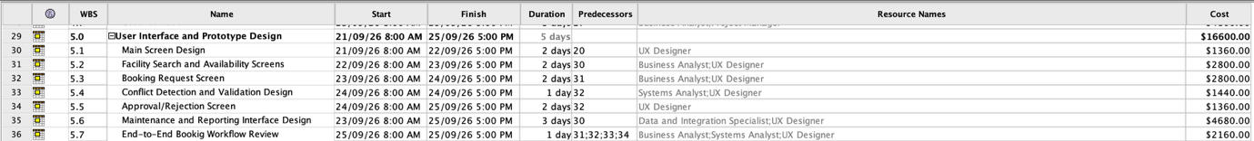
Figure 7.3A ProjectLibre Schedule Table – User Interface and Prototype Design

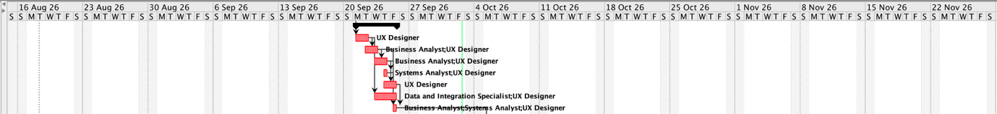
Figure 7.3B ProjectLibre Gantt Chart – User Interface and Prototype Design

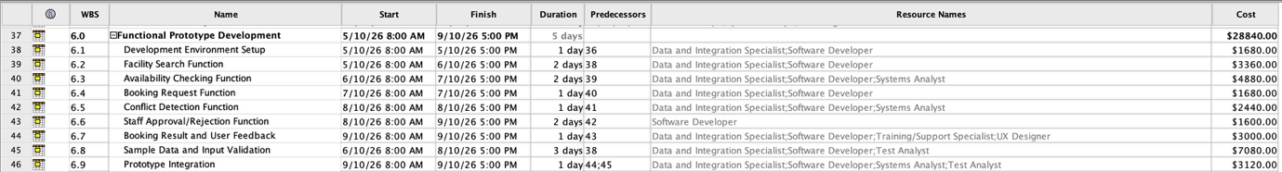
Figure 7.4A ProjectLibre Schedule Table – Functional Prototype Development

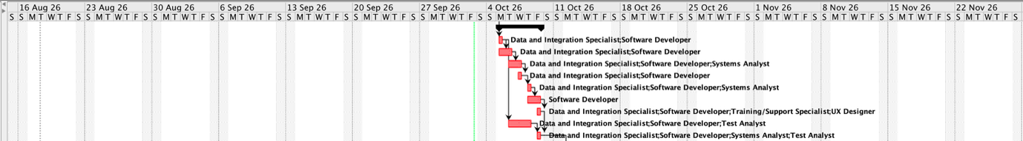
Figure 7.4B ProjectLibre Gantt Chart – Functional Prototype Development

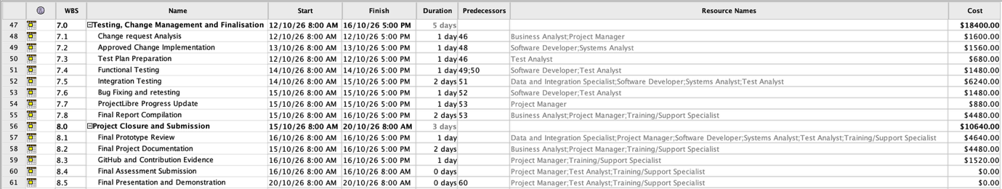
Figure 7.5A ProjectLibre Schedule Table – Testing, Change Management and Project Closure

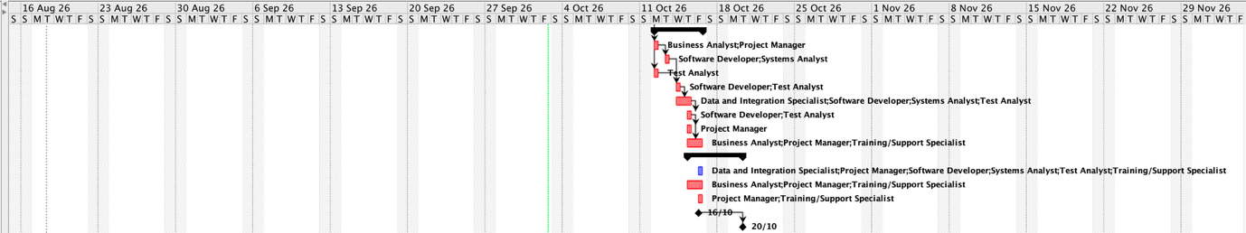
Figure 7.5B ProjectLibre Gantt Chart – Testing, Change Management and Project Closure

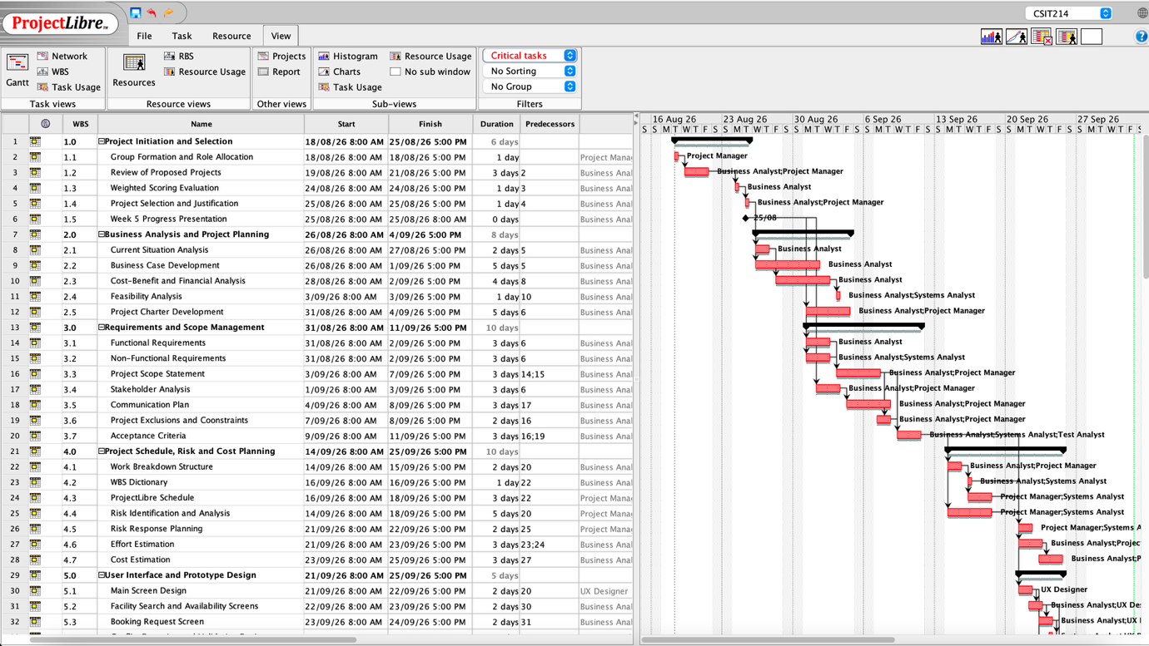
Figure 7.6 ProjectLibre Critical Path

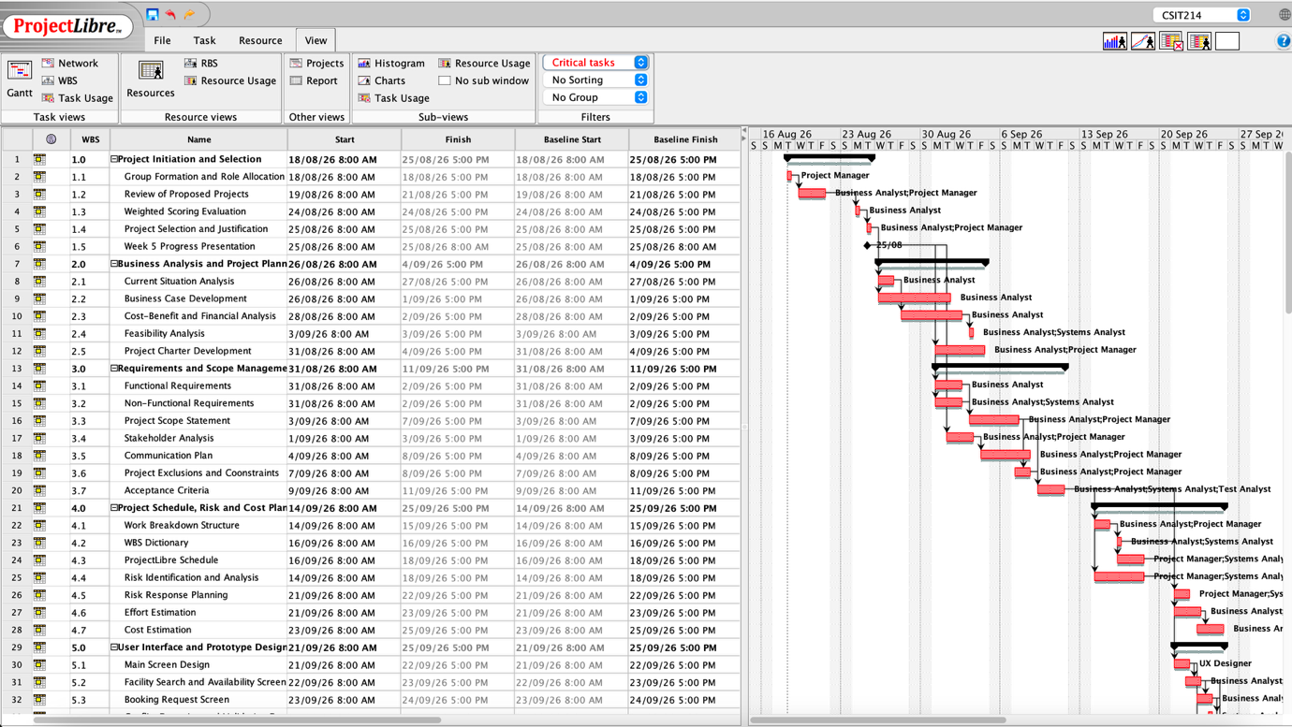
Figure 7.7 ProjectLibre Baseline Schedule

The ProjectLibre cost values are schedule-based task costs automatically calculated from the assigned professional resources, task durations and hourly charge rates supplied by the subject. These values support schedule and resource planning. The detailed overall project effort and cost estimate is presented separately in Section 9 and includes the complete planned professional effort for the project.

- Effort and Cost Estimation
  - Estimation Approach
Two complementary estimation approaches were considered for the project. Function Point analysis was considered as a method for estimating the functional size of the proposed system, while bottom-up estimation based on the WBS and professional project roles was used as the primary basis for estimating project effort and cost. The professional hourly charge rates supplied by the subject were applied to the estimated labour hours. These professional roles are used for project cost estimation and do not represent the number of students in the project team.

9.2 Function Point Estimation Approach
Function Point analysis was considered as a functional sizing technique because it is one of the software effort estimation methods introduced in the subject. The proposed system contains external inputs, external outputs, external queries and internal logical data functions. However, a complete numerical Function Point calculation requires detailed DET, FTR and RET information for individual functions. As this level of detailed data design is not yet available for all functions, a numerical Function Point total is not reported. The project therefore uses bottom-up estimation based on the WBS and professional resource requirements as the primary basis for the effort and cost estimate.

  - Estimated Labour Effort and Cost
Project Role | Estimated Hours | Hourly Rate | Estimated Cost
Project Manager | 180 | $110 | $19,800
Business Analyst | 220 | $90 | $19,800
Systems Analyst | 180 | $95 | $17,100
UX Designer | 140 | $85 | $11,900
Software Developer | 650 | $100 | $65,000
Data and Integration Specialist | 160 | $110 | $17,600
Test Analyst | 220 | $85 | $18,700
Training/Support Specialist | 90 | $80 | $7,200
Total | 1840 hours |  | $177,100

  - Non-Labour Cost Estimate
Cost Item | Estimated Cost
Software and cloud services | $4,800
Development and collaboration tools | $2,000
Integration and testing environment | $2,500
Training and deployment materials | $3,500
Total Non-Labour Cost | $12,800

  - Total Project Cost
Total Labour Cost = $177,100
Total Non-Labour Cost = $12,800

Base Project Cost = $177,100 + $12,800 = $189,900

A 10% contingency allowance is included for uncertainty associated with development, integration and testing.

Contingency = $189,900 * 10% = $18,990

Therefore,
Total Estimated Initial Project Cost
= $189,900 + $18,990
=$208,890

The estimated project cost remains below the maximum approved budget of $300,000 by:
$300,000 - $208,890
= $91,110

  - Estimation Assumptions
The following assumptions were used in the effort and cost estimate:
- The professional hourly rates supplied by the subject are used for labour cost planning.
- The estimated hours represent the effort required for the complete planned project, rather than the actual classroom hours worked by the four student team members.
- Software, cloud, development, testing and training costs are planning estimates.
- A 10% contingency allowance is included to address uncertainty in development, integration and testing.
- Ongoing operational and support expenditure is excluded from the initial project cost and is reported separately in the business case.

References
OWASP Foundation 2025, Application Security Verification Standard (ASVS) 5.0,
https://owasp.org/projects/asvs
ProjectLibre n.d., ProjectLibre Desktop，
https://projectlibre.com/projectlibre-desktop/
Swanson, M, Bowen, P, Phillips, A, Gallup, D & Lynes, D 2010,
Contingency Planning Guide for Federal Information Systems, NIST Special Publication 800-34 Rev. 1, National Institute of Standards and Technology, Gaithersburg, MD,
https://doi.org/10.6028/nist.sp.800-34r1

